

P. Swetha Nagasri

Dadi Teja Sadwika
2520030536
CSE
CO2 – Range Queries

Case Study Topic: LibraryHub – Smart Digital Library Management System (CO2 Focus: B-Tree, B+ Tree & Range Query Structures)

Work Done Summary:
LibraryHub is a digital library management system designed to store, organize, and retrieve book records efficiently. The system uses B-Tree and B+ Tree data structures for fast searching and indexing of books. Range Query Structures are implemented to analyze the number of books available within a specific publication year range. These techniques improve data retrieval speed and support efficient management of large-scale library databases.

Implementation Details:
- Book records are stored using a B-Tree structure.
- B-Tree enables efficient insertion, deletion, and searching of books.
- B+ Tree is used for indexing and sequential access of library records.
- Leaf nodes of the B+ Tree store actual book information.
- Range Query operations help find books published between selected years.
- Segment Tree is used to process range queries efficiently.
- The system reduces search time and improves database performance.
- Users can quickly access required books and generate reports.

Output:

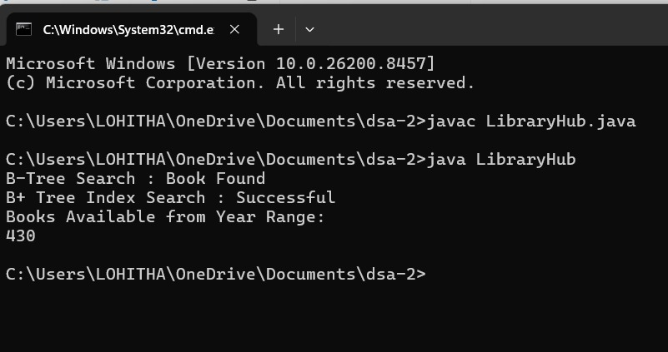

LibraryHub provides efficient storage and retrieval of library records using B-Tree and B+ Tree structures. Range Query operations help analyze books within specified publication year ranges. The system improves search efficiency, data organization, and overall library management performance.

Github link:

